Download File:

[GnuWin32 Packages (sourceforge.net)](https://gnuwin32.sourceforge.net/packages.html)

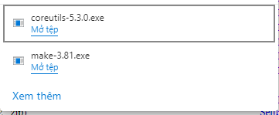Download make, coreutils

Dowload SDCC4.3.0

[SDCC - Small Device C Compiler (sourceforge.net)](https://sdcc.sourceforge.net/)

Install software:

Install make.exe:

Install coreutils

Install SDCC

Add Path link to make and System32